Git Commands Document

Basic git commands (for managing repositories)

git init : initializes a new git repository in the current directory

git clone <repo_url> : clones a repository from a remote URL to your local machine
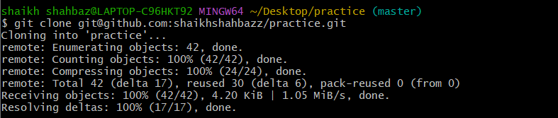

git status : shows the working directory status (which files are modified, staged, etc)
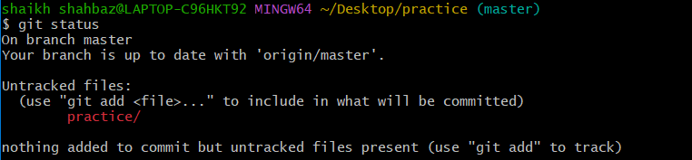

git add : stages a file or files to be committed

git commit -m “message” : commit staged changes to the local repository with a message


git push : pushes committed changes to the remote repository
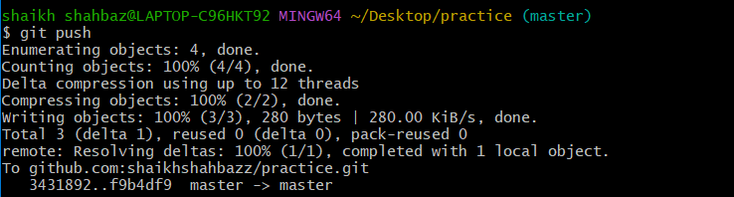

git pull : fetches and merges changes from remote repository to your local working directory

git fetch : downloads objects and refs from another repository (without merging)
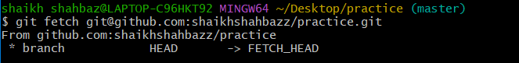

git merge : merges changes from the specified branch into the current branch
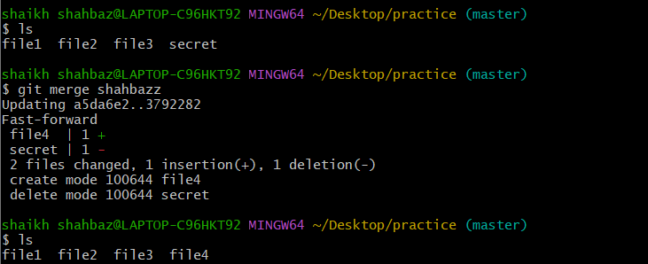

git log : Shows the commit history of the repository
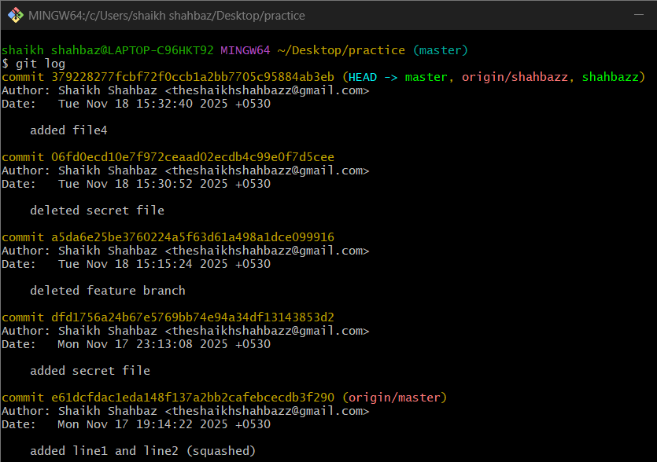

git diff : Shows the difference between your working directory and the index (staged changes)
git diff HEAD~1 HEAD
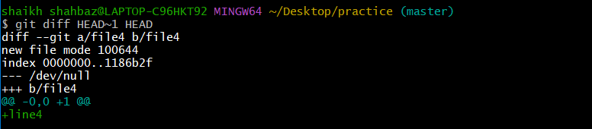

2. Branching commands (Managing branches)

git branch : list all branches in your repository


git branch <branch_name> : Creates a new branch
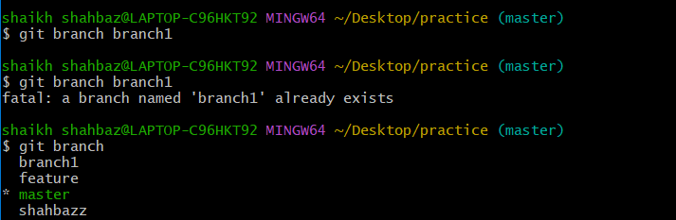

git checkout <branch_name>: Switches to an existing
branch.
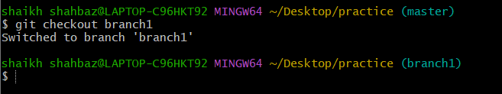

git checkout -b <branch_name>: Creates and switches to a
new branch in one step.
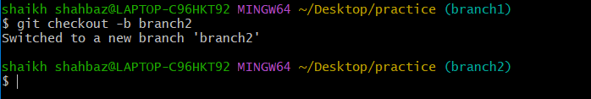

git merge <branch_name>: Merges changes from the
specified branch into the current branch.

git rebase <branch_name>: Applies changes from one
branch onto another branch (instead of merging).
git branch -d <branch_name>: Deletes the specified branch
(locally).

git branch -D <branch_name>: Forcefully deletes a branch
(locally).

git remote set-head origin <branch_name>: Sets the
default branch for the remote repository.

3. Remote Commands (Managing remotes and syncing
with the cloud)

git remote -v: Shows the remote repository URLs.
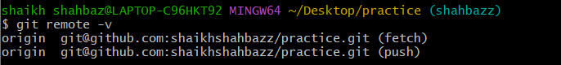
git remote add : Adds a new remote repository.
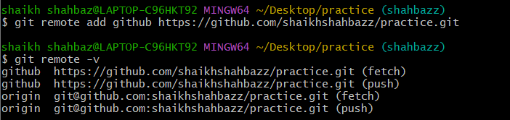

git remote remove : Removes a remote repository.
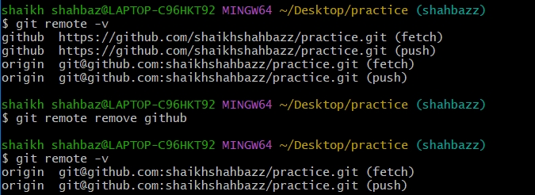
git push origin <branch_name>: Pushes a branch to a
remote repository.
git push -u origin <branch_name>: Pushes a branch to a
remote repository and sets the upstream for the branch.
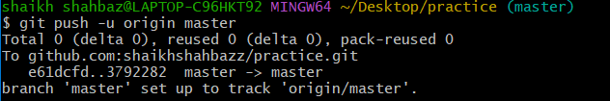

git pull origin <branch_name>: Fetches and merges a
branch from the remote repository.
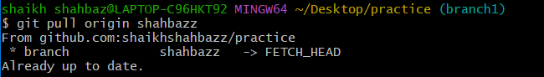
git fetch origin: Downloads objects and refs from the
remote repository.
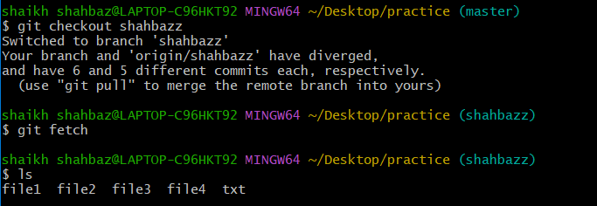
git remote show origin: Displays detailed information
about a remote repository.
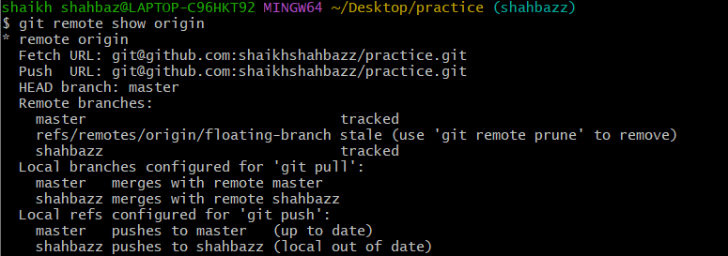

4. Staging and Committing (Managing changes)
git add . : Stages all modified files in the working directory.
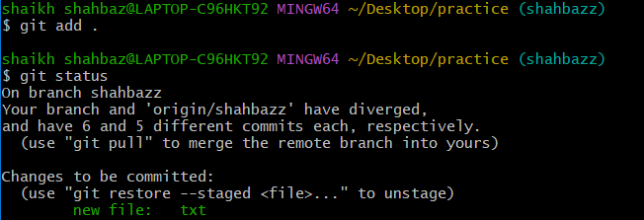

git add -A: Stages all modified files (including file deletions).
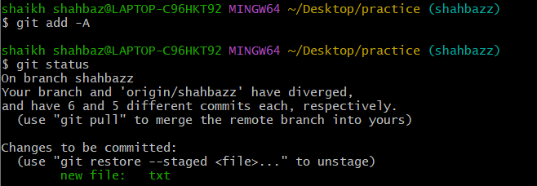

git reset : Unstages a file (reverts it to the working directory).
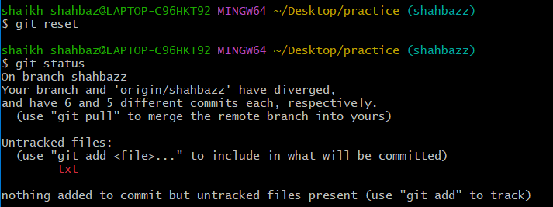

git commit --amend: Modifies the last commit (can change
the commit message or add changes).
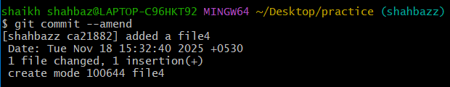

git commit --all: Automatically stages tracked files and
commits them.
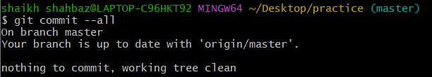
git commit -a: Stages and commits all modified files.
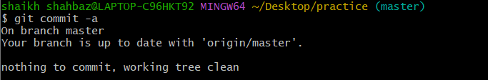
git commit --no-verify: Skips pre-commit hooks while
committing.
git reset --soft HEAD~1: Moves the HEAD pointer back
one commit but leaves your changes staged.
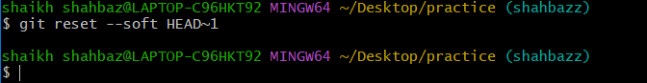
git reset --hard HEAD~1: Moves the HEAD pointer back
one commit and discards changes in the working directory.
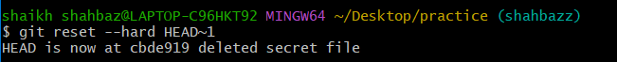

5. Viewing and Comparing Changes (Inspecting changes)

git diff: Shows changes between your working directory and
the index (unstaged changes).
git diff HEAD~1 HEAD

git diff --staged: Shows changes between the index (staged
files) and the last commit.
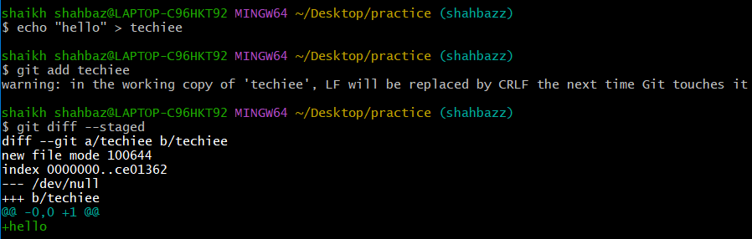

git diff <commit_id>: Shows the differences between your
working directory and a specific commit.
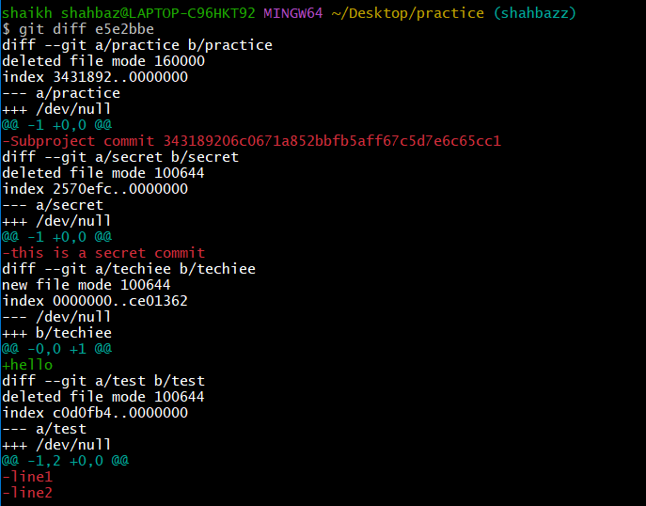

git log: Displays the commit history.
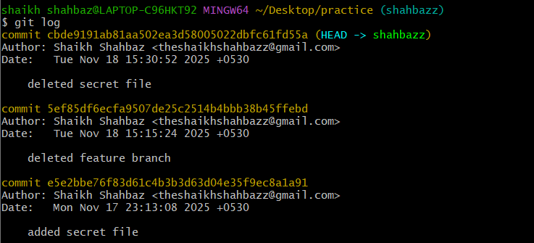

git log --oneline: Displays the commit history in a simplified
one-line format.
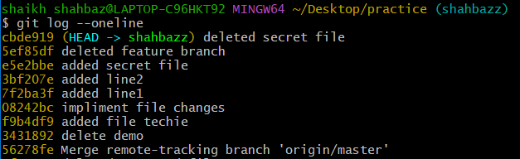
git log --graph: Displays the commit history as a graph.
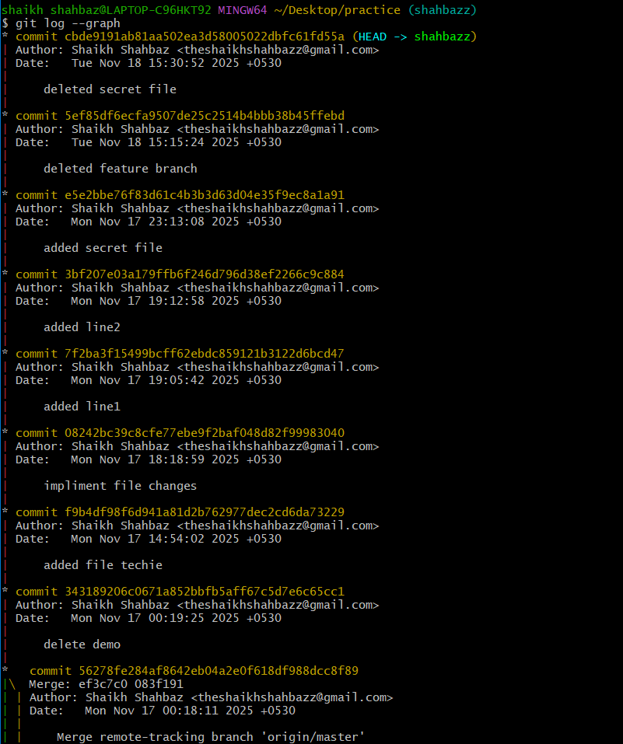

git log --author="name": Filters commits by a specific
author.
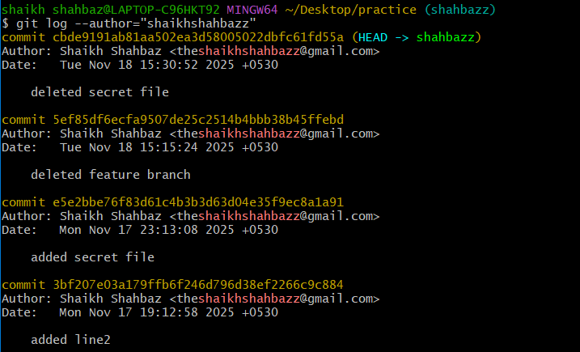

git log --since="2 weeks ago": Filters commits made
after a specific date.
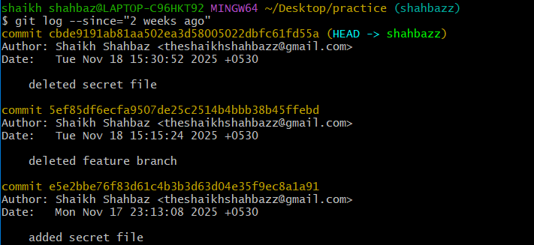

git blame : Shows line-by-line annotations for a file, telling who
last modified each line.

git show <commit_id>: Shows details of a specific commit
(including diff and metadata).
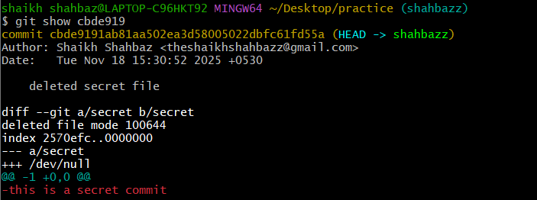
git show <commit_id>:<file_path>: Shows a specific file
at a particular commit.

6. Reverting and Resetting (Undoing changes)
git reset <commit_id>: Moves HEAD to a specific commit,
leaving your working directory intact (can be used with --soft, --
mixed, or --hard).
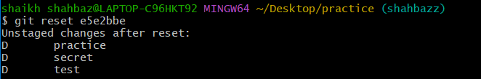
git reset --hard <commit_id>: Resets your working
directory, index, and HEAD to a specific commit (all changes will
be lost).

git reset --soft <commit_id>: Resets only the HEAD to a
specific commit, leaving staged changes.
git reset --mixed <commit_id>: Resets the HEAD and
index to a specific commit but keeps the working directory
unchanged.
git revert <commit_id>: Creates a new commit that undoes
the changes of the specified commit.
git restore : Restores the file(s) in the working directory from
the index or a commit.
git restore --staged : Removes a file from the staging
area.
git clean -f: Removes untracked files in the working
directory.
git clean -fd: Removes untracked files and directories.

7. Stashing (Temporarily saving changes)
• git stash: Stashes the changes in your working directory (both
staged and unstaged).
• git stash list: Lists all the stashes.
• git stash pop: Applies the latest stash and removes it from
the stash list.
• git stash apply: Applies a stash without removing it from the
list.
• git stash drop: Removes a specific stash from the stash list.
• git stash clear: Clears all stashes.
• git stash save "message": Stashes changes with an
optional message for identification.
• git stash branch <branch_name>: Creates a new branch
from the stash and applies it.
8. Tags (Managing versions)
• git tag: Lists all tags in the repository.
• git tag <tag_name>: Creates a new tag at the current
commit.
• git tag -a <tag_name> -m "message": Creates an
annotated tag with a message.
• git tag -d <tag_name>: Deletes a tag locally.
• git push origin <tag_name>: Pushes a specific tag to the
remote repository.
• git push origin --tags: Pushes all tags to the remote
repository.
• git fetch --tags: Fetches all tags from the remote
repository

